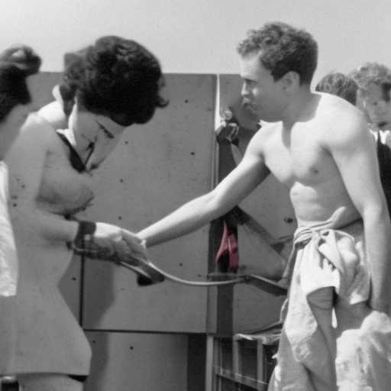
FLAMING SWORD OF ‘PROGRESS’

Us postmodern American straight men
We only want to make Her happy
but our consumer system depends on keeping her unhappy

So, like Sisyphus, we lift that bolder each day because we still love and believe in Her Grace

We want to stay in it
But she is taught by society that we are her adversary;
and sadly, she has believed
enough of this nonsense that her heart can be no Eden to man

A flaming sword of 'progress' blocks the way

